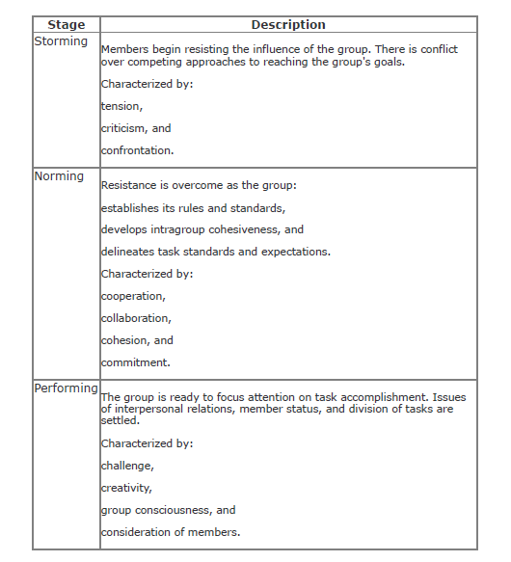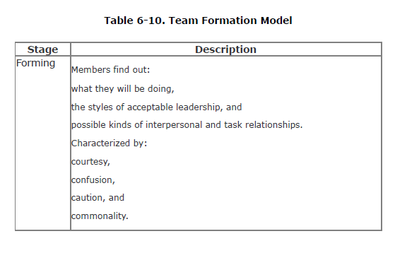1.**What are the four stages of a team’s life cycle formation**?

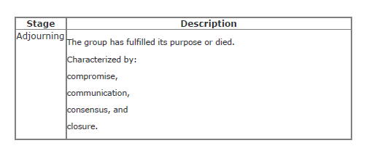2. **What are the four P’s of software project management?**

* **People:** Identifying the roles people play in almost any given project is the first step to a successful project. People are the primary resource on every project, and a well-managed team can greatly increase the chances for success
* **Product:** As the name suggests, this is the deliverable of the project. The project manager should define the product scope to ensure a successful outcome, control “scope creep”; as well as technical hurdles that he or she may encounter.
* **Process:** The third P of project management is Process. Project managers and team members should have a methodology and plan that outlines their approach. Without a clearly defined process, team members will not know what to do and when to carry out project activities.
* **Project:** The fourth and final P of project management is Project. This is where the project manager’s roles and responsibilities come into play. He or she must guide team members to achieve the project’s goals and objectives.

3.**Define any four teamicide techniques?**

* **Defensive management**: Allow the staff to make their own decisions, even if they sometimes make a mistake. Giving them the freedom to make errors is a sign of trust.
* **Bureaucracy:** Avoid turning developers into bureaucrats. Allow the team to believe in its own goals and express your belief in it (and them) as well.
* **Physical separation:** Place workers together so that casual interaction may occur. When people are on the same team, they tend to go into "quiet mode" at the same time and suffer less interruption of their thought flow.
* **Fragmentation of time:** Limit the number of projects, and, therefore, teams, that a person is assigned to. There is high overhead in "switching gears" when moving from one team culture to another.

4. **What are the elements of a project plan?**

The project plan defines the work that will be done on the project and who will do it. A typical project plan consists of:

* A statement of work that describes all work products (specifications, test plans, code, defect reports, and any other product of work performed over the course of the project) that will be produced and a list of people who will perform that work
* A resource list that contains a list of all resources that will be needed for the product, and their availability
* A work breakdown structure and a set of effort estimates
* A project schedule
* A risk plan that identifies any risks that might be encountered and indicates how those risks would be handled, should they occur